**# Cybersecurity Internship** **– Task 4:** Setup and Use a Firewall on Windows

**# Objective:** Configure and test basic firewall rules to allow or block traffic.

**# Tools Used:**

1. Windows Defender Firewall
2. GitHub (for documentation upload)
3. Command Prompt (CMD)

**# Steps Performed:**

1. Open Windows Defender Firewall.  
   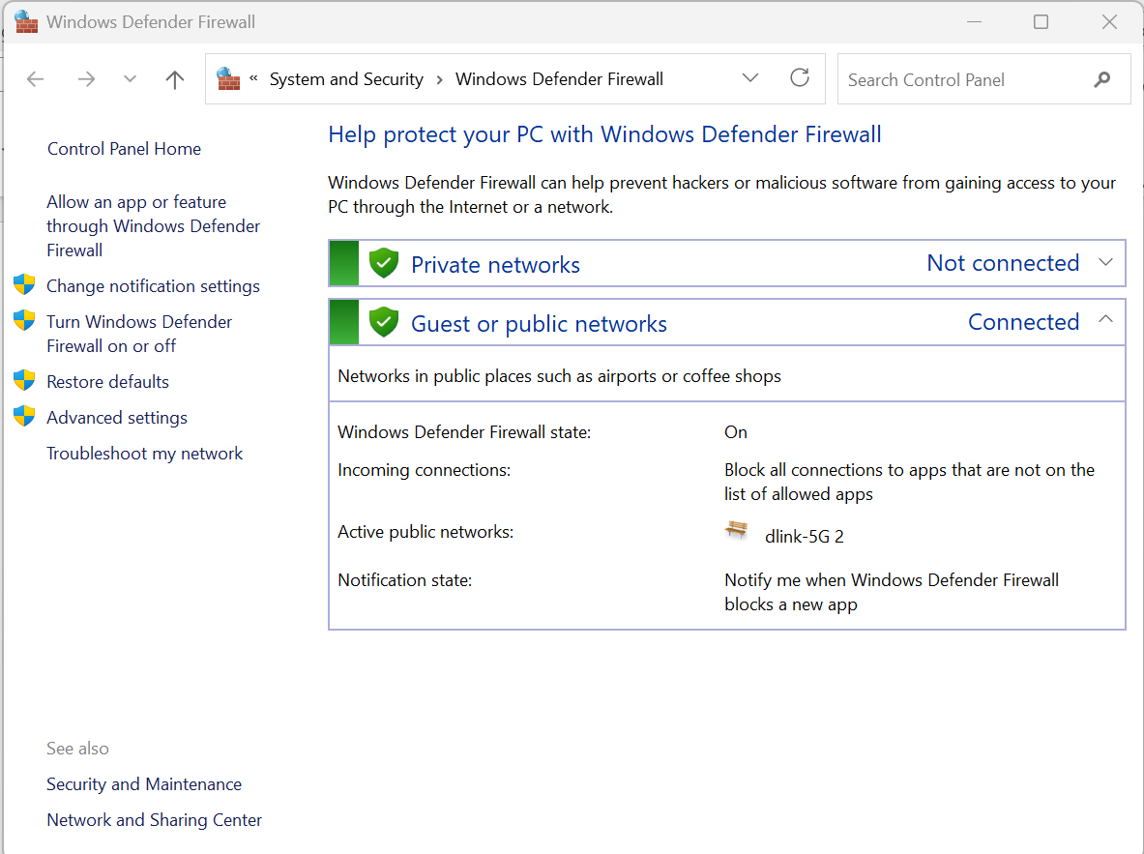
2. Go to **“Advanced Settings”**
3. Then go to Inbound Rules -> New Rules -> Ports -> TCP -> Port 23 -> Block Connections  
   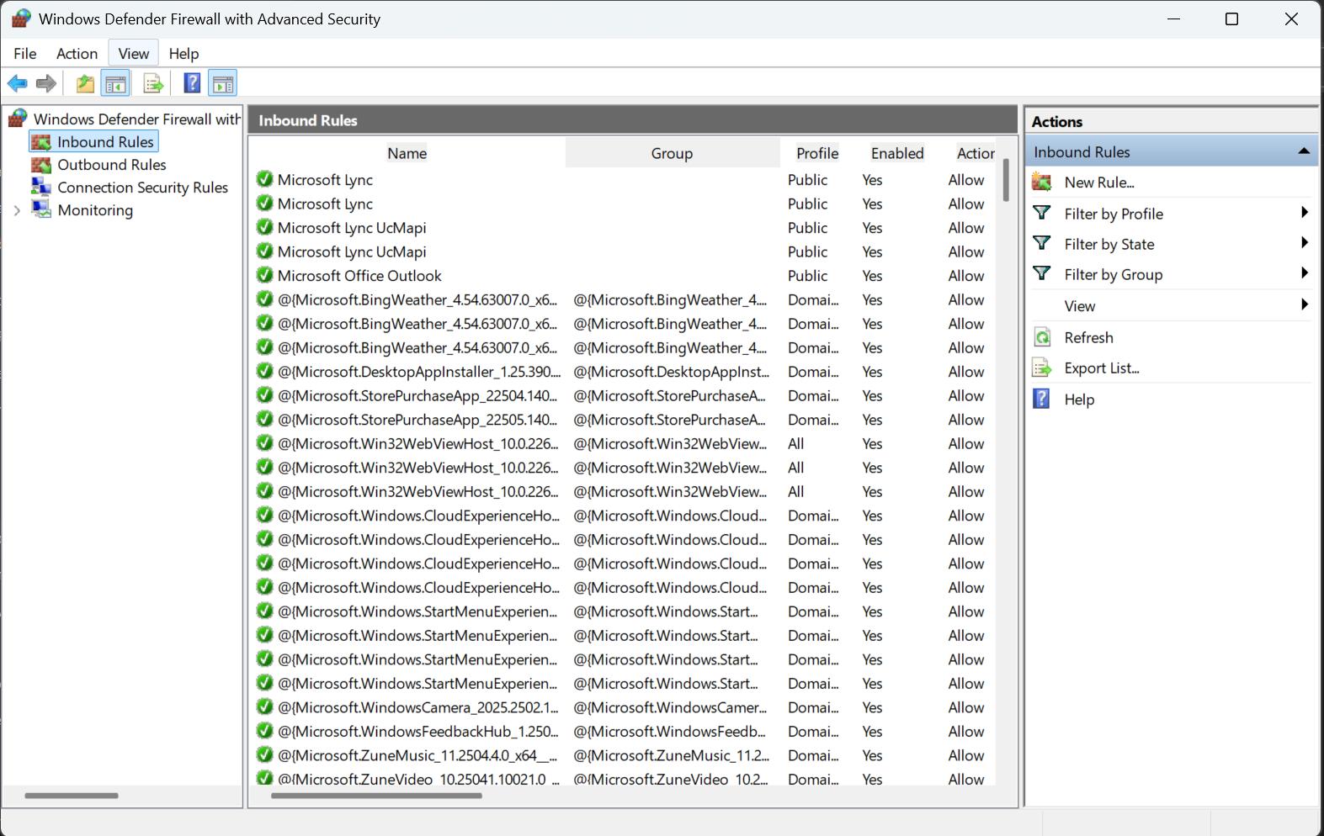  
   A screenshot of a computer

   AI-generated content may be incorrect.  
   Then Block the connection  
   A screenshot of a computer

   AI-generated content may be incorrect.  
   A screenshot of a computer

   AI-generated content may be incorrect.
4. Now that the Policy is created in Firewall now, we will test it.
5. For testing we used Command Prompt and try to telnet 127.0.0.1 with port number 23 which we just blocked.
6. When we tried doing telnet we got a error message saying “Error: 740 - Elevated permissions are required” so we enabled the Telnet Feature first and then tried to telnet and got the error “Connecting To 127.0.0.1...Could not open connection to the host, on port 23: Connect failed” which ultimately means Telnet is blocked successfully.  
   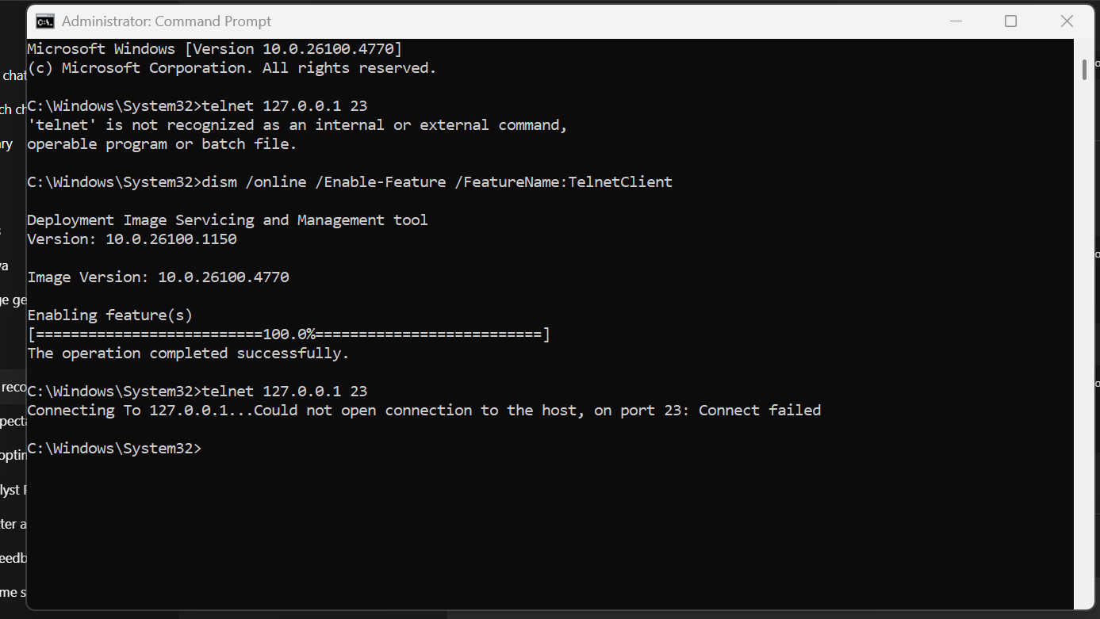
7. **# Conclusion:**

By using Windows Defender we were successfully able to blocked the port or service.